WIJAYAWARDHANA W.A.H.A.

2019/E/166

SEMESTER 05

28 OCTOBER 2022

DECLARATIVE PROGRAMMING – LAB 08

EC 5080 – SOFTWARE CONSTRUCTION

01.

public class Student {  
 private String name**;** private String regNo**;** public Student(String name**,** String regNo)  
 {  
 this.name = name**;** this.regNo = regNo**;** }  
 public void setName(String name)  
 {  
 this.name = name**;** }  
 public String getName()  
 {  
 return name**;** }  
 public void setRegNo(String regNo){  
 this.regNo = regNo**;** }  
 public String getRegNo()  
 {  
 return regNo**;** }  
}

02.

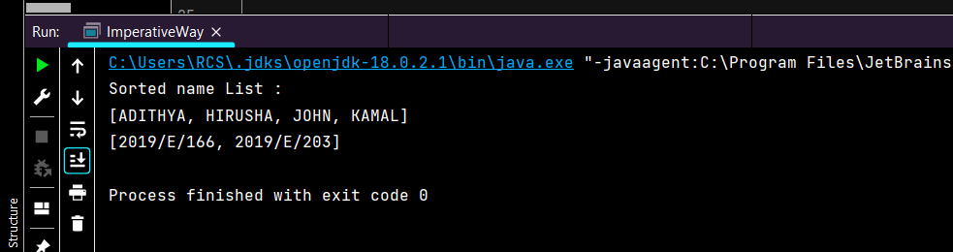

03.

